CENWP-OD-B 07 July 2023

MEMORANDUM FOR THE RECORD

SUBJECT: 23BON045 MFR AFF Valve 15 PL and CH morts

On the morning of 06 July, Columbia River Inter-Tribal Fish Commission (CRITFC) Biologists notified Bonneville Project Biologists of three Pacific Lamprey mortalities and on juvenile Chinook salmon found on the Valve 15 trash rack in the Adult Fish Facility (AFF).
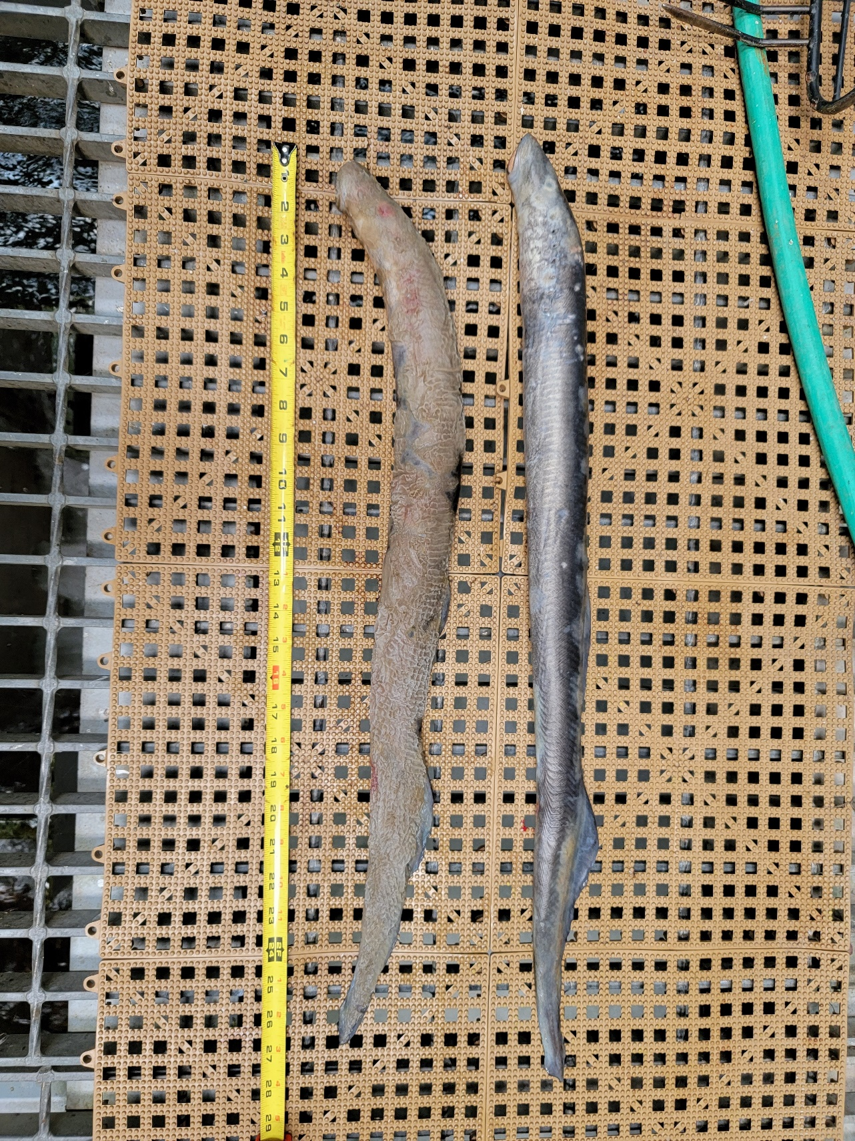
The fish were scanned for PIT tags, inspected, and returned to the river.
- Species – Pacific Lamprey (Entosphenus tridentatus)
- Origin – Unknown
- Length –
  - Photo 1 - 73.7 cm, 67.9 cm
  - Photo 2. - 71.8 cm
- Marks and tags – None
- Marks and Injuries found on carcass – None
- Cause and Time of Death – Unknown
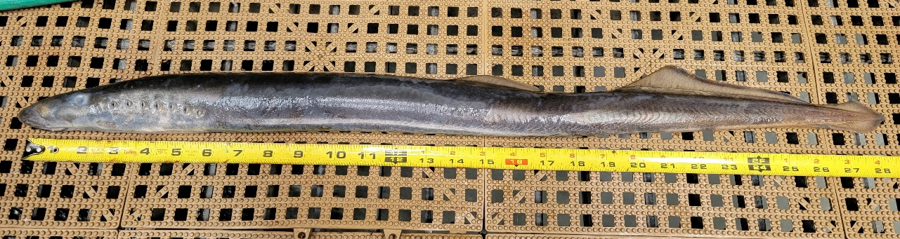
- Future and Preventative Measures – None
Photo 1.
Photo 2.
- Species – Chinook Salmon (Oncorhynchus tshawytscha)
- Origin – Unknown (likely hatchery)
- Length – 24.1 cm
- Marks and tags – Removed adipose fin
- Marks and Injuries found on carcass – slight descaling
- Cause and Time of Death – Unknown
- Future and Preventative Measures – None
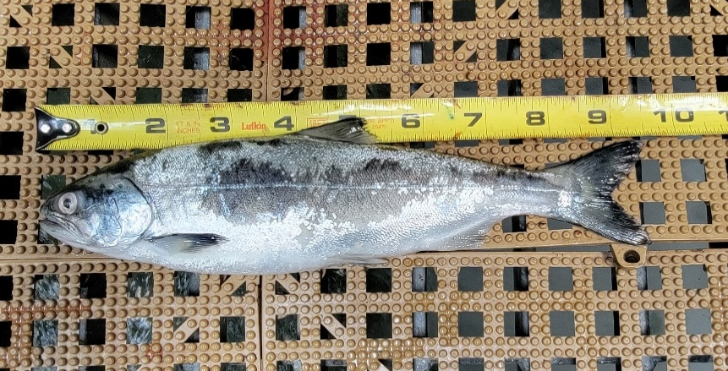
Photo 3.

Sincerely,
Bonneville Project Fisheries

